Articles to use:

<https://corporatespring.com/men-say-yes-women-say-not-yet/>

Women are more self-aware of their abilities. Men often exaggerate their abilities.

Men: if them…why not me?

Women: if not them…why me?

<https://www.americanprogress.org/issues/women/reports/2020/03/24/482141/quick-facts-gender-wage-gap/>

The Gender Wage Gap – the difference in earnings between men and women

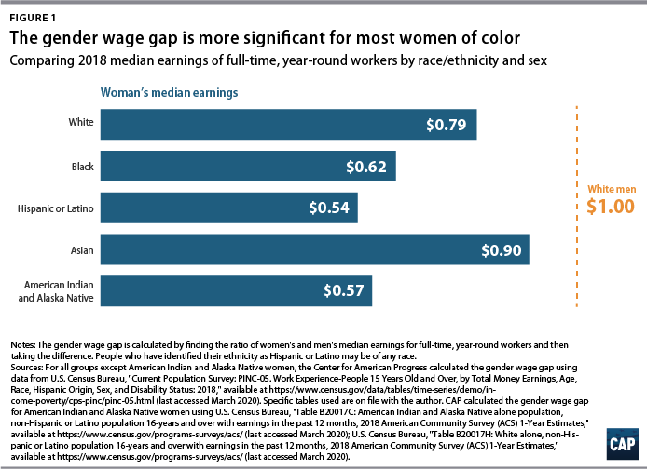

Reasons for the wage gap:

* Discrimination. Gender bias is still very much alive whether people are conscious of it or not.
* “Only 19% of civilian workers had access to paid family leave through their employers and only 40% had access to short-term disability insurance benefits to deal with their own medical needs” 🡪 this leads to men having more years of experience.
* Industries that are predominately women such as childcare, education etc. tend to pay lower wages than industries dominated by men including trading, construction, etc.

<https://futurewomen.com/hotlists/5-reasons-gender-pay-gap-exists/>

The world economic forum predicts that it will take another 217 years before the gender pay gap finally closes.

Female dominated industries: childcare, social work, teaching and nursing.

Having a family effects how much time a mother can work. Having children can be the deterring factor if a woman succeeds in her career or not.

Possible page titles:

* **Should having children effect a women’s ability to pursue her career of choice and her ability be successful in the industry?**
* **The beauty of motherhood and the evilness that society has connected to it.**

Every website I have done research on has mentioned motherhood. Not only do men statistically excel in the workplace but they get to reap the benefits of having a family without it affecting their career.

<https://www.theatlantic.com/business/archive/2016/12/opting-out/500018/>

10% of highly educated mothers stay home

Essentially, women immediately connect with their child once he/she is born making it extremely difficult for them to give 100% of their efforts to either the child or their career. Children also brings less flexibility in a mother’s work schedule. Once a child is born their job either wasn’t flexible enough, didn’t pay enough, or wasn’t fulfilling enough.

“Women are promoted slower and are judged more harshly and they aren’t compensated the same”

If a woman is pregnant, they’re less likely to be promoted even if their competition is less experienced.

After the children enter their teen years it is difficult for the mother to fully reenter the professional world. You lose “professional currency and earning power” when you are out of the professional workplace for so long.

“The women who work feel badly about being disconnected from their children, the ones who stay home dream about going back to work”

Admits a global pandemic, working from home has become normal. Maybe, in the near future it will become normalized to carry on a full-blown career while raising children at the same time.